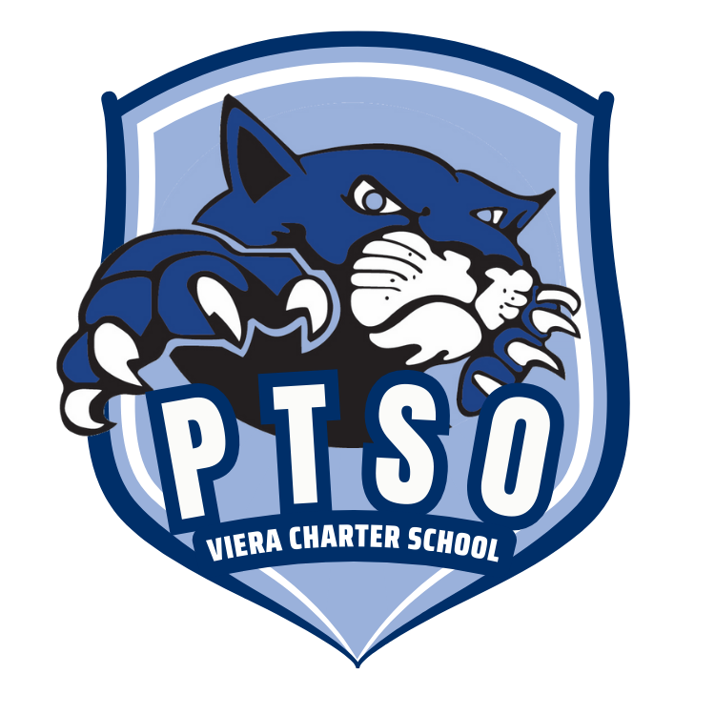
Viera Charter School PTSO
Funding Request Form
2026-2027

VCS PTSO funds various activities and projects that benefit Viera Charter School. Completion of this form will assist the PTSO to allocate available funds. Submission of this form does not guarantee funding and purchases prior to approval will not guarantee reimbursement. Requests are typically voted upon at PTSO monthly meetings and the requestor must be a paid (in good standing) PTSO member in order to request funding from VCS PTSO. An in-person presentation will help board members make a more informed decision prior to casting a vote and is highly encouraged. Quotes, invoices and receipts are mandatory. If the approved request requires funds over the original amount requested, PTSO may not be able to fund the excess amount.
Please submit a completed form to vcsptso@gmail.com with the subject “funding request”. Also, to confirm school Administration is aware of your request, please obtain a signature before submission.
Date: _________________ Name of Requestor(s) ______________________________________________
Signature of Requestor(s) ____________________________________________
Requested Amount (include shipping/handling & note that PTSO will not cover sales tax) $_________________________
Request Category (circle one):
ADMINISTRATIVE STEAM
TECHNOLOGY (HARDWARE & SOFTWARE) EQUIPMENT
OUTDOOR IMPROVEMENT EDUCATIONAL SUPPLIES
INDOOR IMPROVEMENT EDUCATIONAL SUBSCRIPTIONS
FURNITURE OTHER
What is being requested? Describe the item, activity or service with as much detail as possible including website or other resources. _______________________________________________________________________________________________
_______________________________________________________________________________________________
Who will benefit from this request (school wide, grade level, class, group, club, teacher, etc.)? If Students, approximately how many students will benefit from this request?
_______________________________________________________________________________________________

_____ Requester has communicated request with a VCS Administrator and has confirmed request is not within VCS/CSA budget or request is unavailable for use.

_____ Requester is a Viera Charter School PTSO member

_____ Requester will present at meeting (meeting dates on VCSPTSO.com) Date: __________________________

VCS Principal’s signature: __________________________________________________
FOR VCS PTSO INTERNAL USE ONLY:
_____ Approved ____ Denied Comments: _____________________________________________________
Date: ____________ Check #: __________ PTSO Signature: _______________________________________________

